ETWINNING PROJECT
APPETITE COMES WHILE SINGING

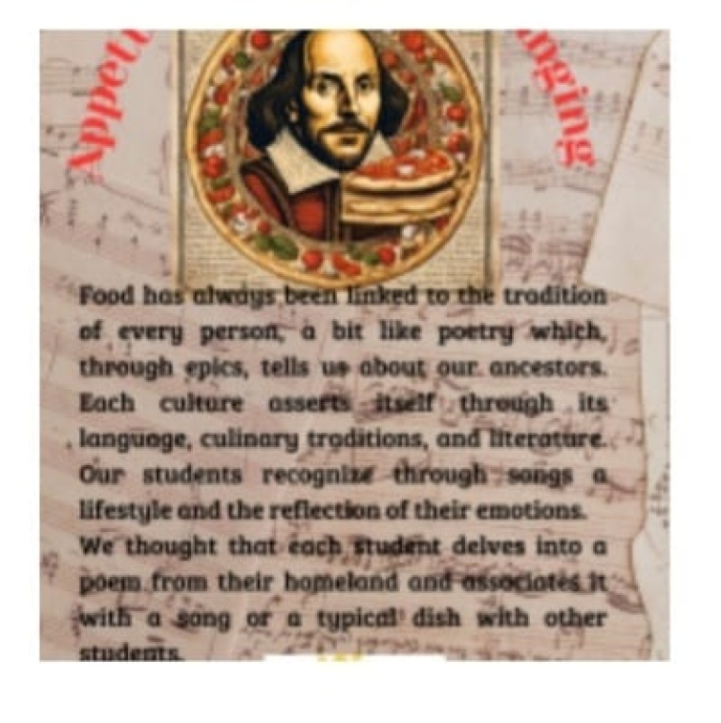

Project introduction
APPETITE COMES WHILE SINGING – DESCRIPTION

Food has always been linked to the tradition of every person, a bit like poetry which, through epics, tells us about our ancestors. Each culture asserts itself through its language, culinary traditions, and literature. Our students recognize through songs a lifestyle and the reflection of their emotions.
We thought that each student delves into a poem from their homeland (not only Italy, since our school is multi-ethnic) and associates it with a song and a typical dish; we would like to exchange our experiences with other students.

GOALS
English language skills
Italian language skills
Cultural belonging
Digital skills
Intercultural and inclusion skills
Cooperation between students, teachers, and families
Communication with foreign students while getting to know the way of teaching in other countries
Knowledge of students from different cultures
Emotions and feelings, openness towards others
Interdisciplinary skills

EXPECTED RESULTS
Students learn new words and constructions of the English language
Students learn the language of poetry
Students understand the value of their culture
Students understand the potential of music
Students collaborate
Students deal with realities that are different from their own

FIRST WEBINAR

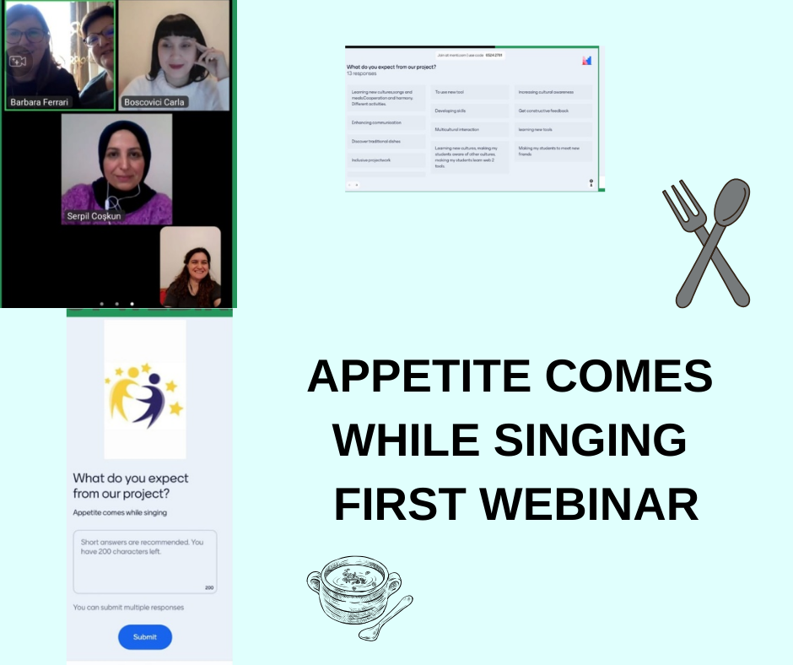

PROJECT BOARD

